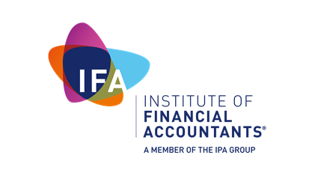

IFA retired application form
2017

Institute of Financial Accountants
The Podium, 1 Eversholt Street, Euston, London NW1 2DN
T: +44 (0)20 7554 0730 E: membership@ifa.org.uk
www.ifa.org.uk
The Institute of Financial Accountants registered in England No. 9350923 Limited by Guarantee
Registered office: 6th Floor, 60 Gracechurch Street, London EC3V 0HR

Eligibility for retired membership
We offer a retired membership level and to be eligible you will need to meet the following criteria:
- fully retired from all remunerated activity; and
- be either an Associate or Fellow of the IFA.

You will also need to surrender your IFA practising certificate if you previously held one.

By accepting this level of membership your rights to act in a voluntary role are not affected. However, if you do provide voluntary services you will need to comply with the IFA’s CPD requirements.

The IFA reserves the right to request evidence to support your retired membership application.

I am applying for: | YES | NO
IFA retired membership

Completing and submitting your application form
Complete ALL sections of the form using block capitals and black ink. Remember to enclose ALL your supporting documents and the application fee.
The information that you provide must be true, correct and up to date. It is your responsibility to inform us of any changes within 10 working days.
Forms which are Incomplete, illegible or where the application fee and supporting documents are missing will be returned unprocessed.
There are two ways to submit your application form, supporting documents and retired annual fee:
- Email to membership@ifa.org.uk
- Post to:
Institute of Financial Accountants
Membership Department
The Podium
1 Eversholt Street
London
NW1 2DN

Next steps
Once we have assessed your application we will contact you with a decision about your eligibility for membership and the level of membership we can offer you.
We aim to provide a response within 15 working days. However, during October – December this may take longer as existing membership renewals are prioritised.
Personal details
Membership number
Title
First name
Middle name
Surname
Date of birth
Home address
Home number
Other address

Work number
Mobile number
Email address

 | YES | NO
Do you hold membership with another professional accountancy body?

 | YES | NO
Are you in public practice?

 | YES | NO
Do you hold a practising certificate with another professional accountancy body?

Member obligations
Your undertakings |  |  | Tick box
I agree to adhere to the IFA’s Bye-laws, Code of Ethics, Best Practice Code, Members’ Handbook and any other guidance notes issued by the IFA.
I declare that I have met the retired criteria as outlined in this form, and if at any stage I return to paid work I shall contact the IFA to change my status and pay the appropriate fees applicable.
I declare that:
- to the best of my knowledge and belief all of the information given in this application is correct;
- I understand that I must inform the IFA of any material changes to the information I have provided within 30 days of the change; and
- I understand that the IFA reserve the right to contact me to verify any of the information provided in this form.
Your annual CPD declaration |  |  | Tick box
I have complied with the IFA’s CPD requirements in the preceding 12 months and I can provide evidence of this if requested.
I am exempt from the IFA’s CPD requirements.
Please provide reason for exemption

Print your full name | Signature | Date (DD/MM/YYYY)
 |  | / /

IFA Data Protection Policy
IFA takes your privacy seriously. All personal information provided to IFA on this form or through any other method of communication is collected and held in accordance with the Data Protection Act 1998. Non-sensitive information may be passed to third party and partner organisations for the promotion of goods and services relevant to financial accountancy and tax.
We will treat your personal information in accordance with the data protection legislation. We will use your information for administration, communication and research. We will also use your information to carry out our responsibilities as a regulator and as a professional body. To do this, we will share your information with other organisations as required by law.
We may transfer your information outside the European Economic Area (EEA) e.g. IPA Group These countries may not have similar data protection laws to the EEA, so if we do transfer your information we will take the necessary steps to ensure that your privacy rights are still protected.
Copies of the IFA Data Protection Policy and the Privacy and Cookie policies are available to view on the IFA website www.ifa.org.uk/dataprotection
Before we accept your application, we may need to obtain ‘satisfactory evidence’ to confirm your identity and we may use electronic verification for this purpose. We may also need to obtain such evidence after we have begun to act on your application. Although a record of our enquiry will be entered on your record it will not affect your credit history.
In certain circumstances, we may also need to obtain evidence confirming the identities of third parties, the source of any funds or other property, the purpose of any instructions or any other matter.

Method of payment
Please note, if your payment bounces or is returned to us; or cancelled at a later date; then the IFA reserve the right to apply an administration charge.
Our membership fees can be viewed at www.ifa.org.uk/membershipfees

The IFA Retired annual subscription is £75.00

Choose your method of payment | Tick box
Payment by BACS – I confirm that I am paying my fees by BACS. This method of payment provides a fast and efficient means to renew your annual membership. Simply make payment to:
Institute of Financial Accountants
Sort code: 40-40-32
Bank account number: 81108603
IBAN: GB96MIDL40403271640623
BIC/SWIFT: MIDLGB2109A
Please note: If paying via this method you must ensure that your bank uses your membership number, initials and surname as your BACS payment reference.
You remain liable to pay any bank charges incurred. Charges not paid may result in your membership not being renewed until all charges are received in full.
Sterling cheque or banker’s draft drawn on a UK bank – I confirm that I am paying my fees by sterling cheque or banker’s draft, made payable to the Institute of Financial Accountants.
Payment by debit/credit card – I confirm that I wish you to take the full amount.
Please tick this box and provide your card details below.

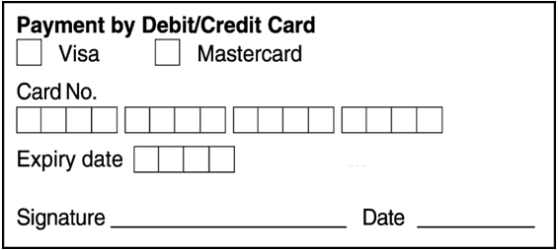

© Institute of Financial Accountants 2017 07/17

